 | 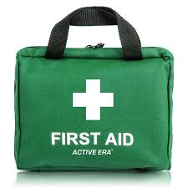  First Response Training

The Trainers are offering the following sessions towards a First Response course. If you only need one of these Modules, that is fine. Just sign up for what you require to complete the qualification.

You must also complete the e-learning module on-line. This may be done before or after these evenings, but the qualification cannot be entered on GO until it is completed. Please note that all 3 Modules are required to gain the qualification.

DATE | MODULE | Venue | TIME | ATTEND
Thurs. 15th August 2024 | Module 1 | The Hub, Harold Wood. RM3 0QA | 7.30 p.m.
Wed. 7th August 2024 | Module 2 | Zoom | 7.30 p.m.
Tues. 20th August 2024 | Module 2 | Zoom | 7.30 p.m.
Wed. 14th August 2024 | Module 3 | Zoom | 7.30 p.m.
Wed. 21st August 2024 | Module 3 | Zoom | 7.30 p.m.

Please complete the attached form and email to County Office before 31st July 2024 to book your place.
Log on details will then be sent.

Remember that the 2-hour renewal option is no longer available.

------------------------&-----------------------------------------------------------------------------------------------------------

First Response Training August 2024

Name …………………………………………… Division ………………………………………

Membership Number ………………………

Unit ………………………………………………………. Rainbows/Brownies/Guides/Rangers

Telephone………………………… Email ……………………………………………………………………

Reply to: - Girlguiding Essex West – office@girlguidingessexwest.org.uk

Once you have booked the zoom links will be sent to you

