**Rainbow & Brownie Day**

**‘On your Marks’**

**21st September 2024**

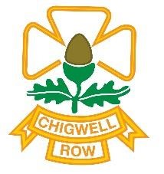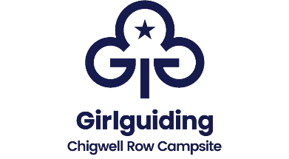

**Managed by London over the Border County**

**Take your marks and get ready for a sporting themed Rainbow and Brownie Day event at Chigwell Row:**

The event will run from 10:30-4:00 £20 for the Day (Leaders, and Young Leaders are free – please come prepared to help on the bases!)

How many activities will your girls be able to fit into one day? There will be lots to choose from! Will you climb the wall, zorb around the pool, shoot an archery arrow or a cork gun, bounce on a bouncy castle, pedal a go kart or just take it easy in the ice cream chill out area. The choice is yours! Come with other members from your Unit and your Leaders. There may be age restrictions for younger children and weight restrictions apply on some activities but there will be plenty of others to do instead.

You will need your Unit First Aid Kit and something to sit on or under for lunch time, eg a gazebo and groundsheet. A packed lunch and water bottle, a cagoule or a waterproof jacket, sun hat, your permission form and a small bag to carry all your items in would be helpful! The Chigwell Row Shop will be open during the day for souvenirs drinks etc, so don’t forget your pocket money!

While we aim to provide lots of adventurous activities for the girls to do, for the event to be successful and so you can all spend time with your girls, each participating Unit is asked to run a small game or activity. This could be a sports game or face painting or cooking or a craft. A larger group of Leaders from a District may wish to join together to organise and run an activity. All activities should be free of charge. Alternatively some Leaders may wish to supervise an activity which we will provide. We will ask you when you book what you would like to do.

How to Book:

Leaders, please book with us on behalf of your whole group. **Just return the event information form with your estimated numbers as soon as you can to help us plan.** You can adjust your numbers up to 22nd July when a payment request will be sent to you to be paid by 31st July. It may be possible to add more people after this date but we can’t guarantee this. **Receipts will then be emailed, together with the Permission Form and further information to help you plan for the day.**

**For more information contact us at**

Girlguiding Chigwell Row, 141 Lambourne Road, Chigwell Row, Essex, IG7 6EN

website: [www.chigwellrow.org.uk](http://www.chigwellrow.org.uk/)  info@chigwellrow.org.uk Telephone: 020 8500 2450